­­

**Drop in Grief Support Group for Spouse/Partner Loss**

**Being with others who get it**

**Hand in Hand** - For older adults who have experienced the death of a spouse or partner over the last two years. Meets the 1st and 3rd Tuesday of the month. Please contact facilitator before joining the group.

**Time:** 10:30am – 12:00pm

**Place:**  JCFS, 5150 Golf Rd, Skokie

**Fee:** $10.00 a session (adjustable)

**Contact:** Marsha Raynes, LCSW, (847) 745-5408

**Email:** MarshaRaynes@jcfs.org

­

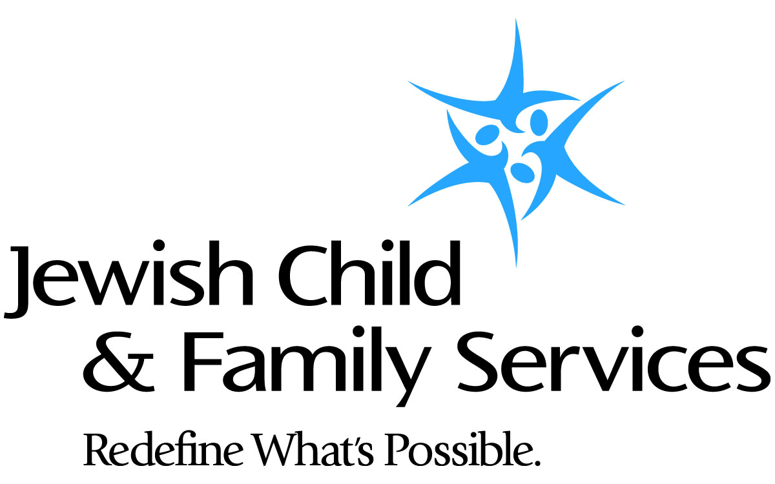

For access to help, call 855.ASK.JCFS (855.275.5237), email [ask@jcfs.org](mailto:ask@jcfs.org) or visit **jcfs.org.**

JCFS is a partner with the Jewish United Fund in serving our community.

